**PROJECT “BANK MANAGEMENT SYSTEM”**

**EXECUTIVE REPORT**

**Team Members**

**SE 21031 Musadique Hussain**

**SE 21034 AZIB Khalid**

**SE 21046 Sahil Krishna**

***BANK MANAGEMENT SYSTEM***

The project is a GUI application in Python named a Bank management system where people can register their accounts. Here is the source code of the management system.

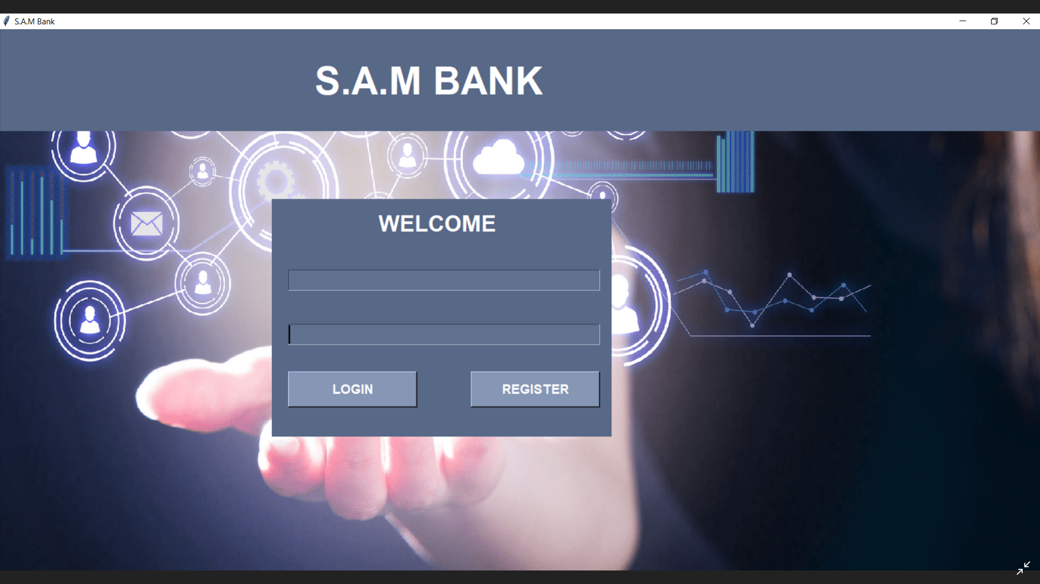

This is our first interface of the Bank management system. In this interface there are two options in this interface one is register and the other is log in. In the register option, a user can create his/her bank account. About the log-in option, There are two entries in the label where the user can enter his/her bank information.

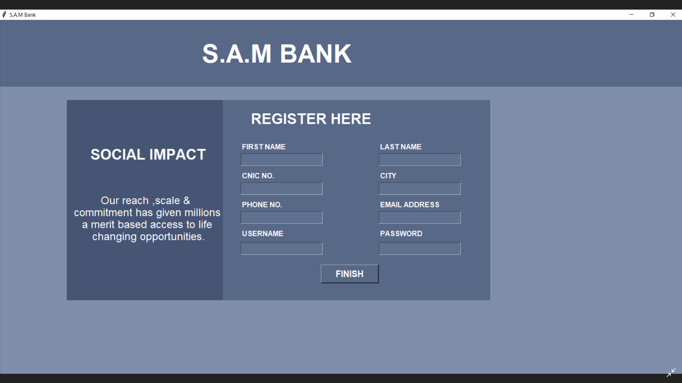

***Here is the second frame of the bank management system. After clicking the register button the second window opened her you can fill in all the requirements for the bank account.***

***All the data are connected with Microsoft access so when the user registers the account all the data will appear in the Microsoft access database system.***

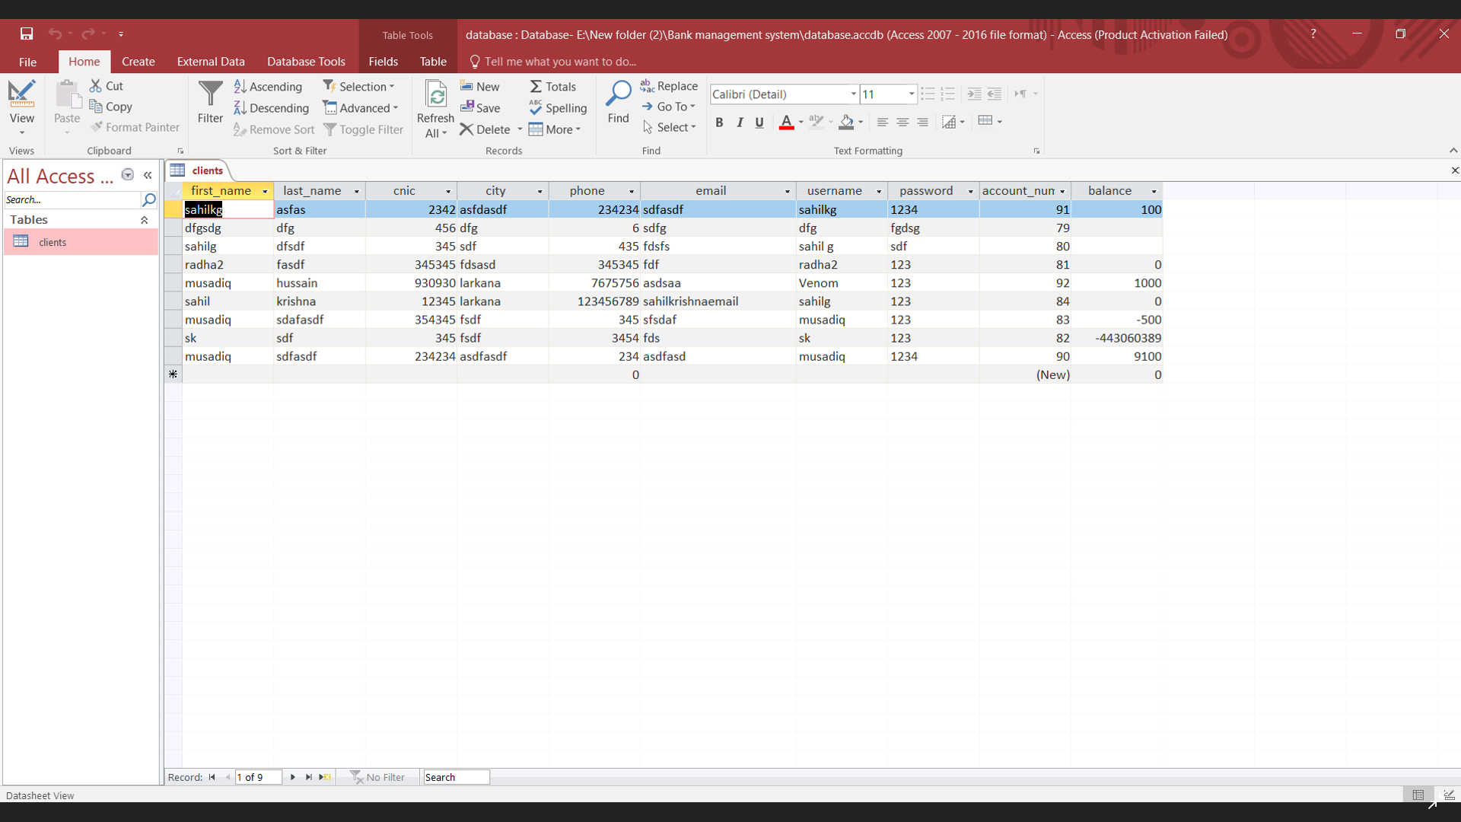

Here is the data that is connected with Python. For connecting the data with the GUI application we have imported pyodbc module. What this module does is connect the data with the GUI application. The main benefit of this module is that the whole data management system will store in an access file.

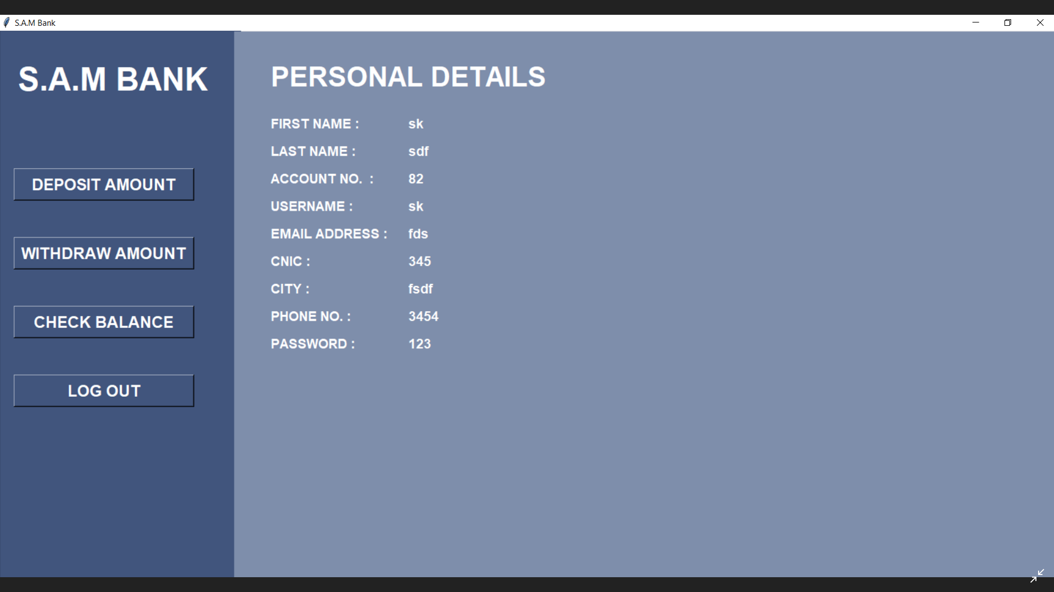

**Deposit Amount Section**

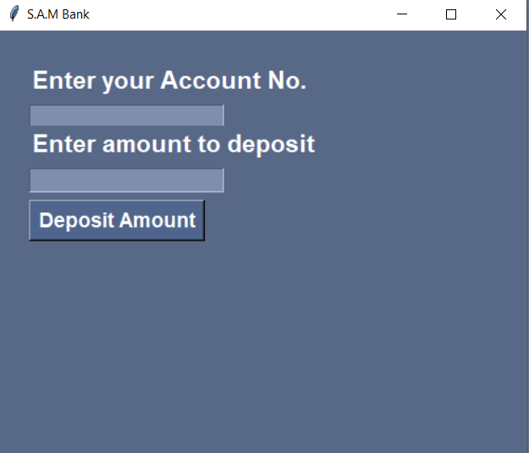

Withdraw Amount Section

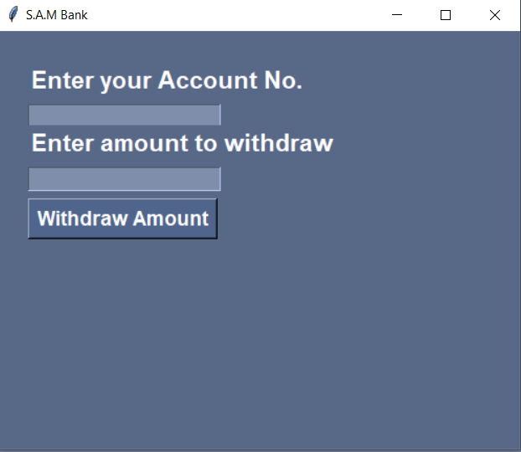

**Output**

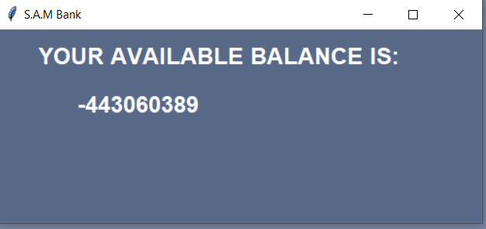

This is the Dashboard of the GUI Application. In the Dashboard, All the customer records appear and on the left side of the corner, there are several options where users can withdraw, display or check the balance. In the deposit window, the user can add money, and in the withdraw option user can make money from the GUI application. There is a little check balance option where the user can check his/her money on the GUI.

**Here is the source code of GUI applicaton of Bank management system.**

